

**How to Setup Barcode Scanning on your Droid**

Go to play store on your phone and search Barcode Scanner

Choose this one

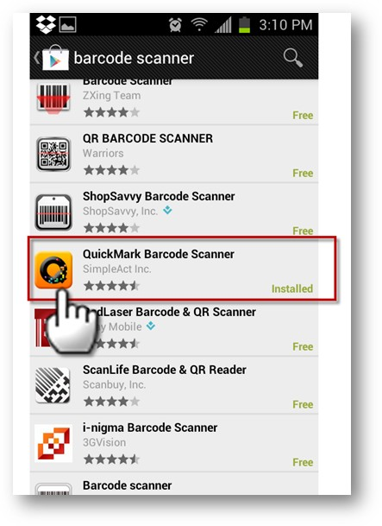

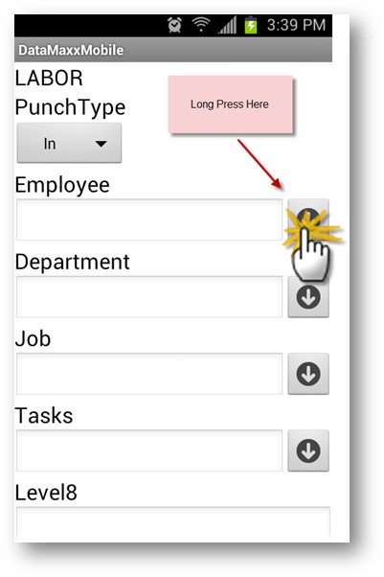

Open Datamaxx on the Device and go into labor

If you have multiple scanners choose the Quick Mark as default and check the box below to make it default

